Name Quang Huynh Date 11/8/17 Color Green

Properties of Matter SUPER HERO Project

Your job is to create a brand-new superhero with amazing physical and chemical properties like we have been learning in class. You will draw a picture/comic strip of your superhero AND write a paragraph to introduce your hero to the world. Your paragraph and drawings will show how the hero uses their properties. Be creative!

Your project must include:
- A colored picture (self-drawn) or comic strip of your superhero with labels showing at least 5 properties of matter in action
- A paragraph that introduces the hero and how the superhero uses at least 5 properties of matter (typed or very neatly written)
Grading Rubric
Category | 10 | 8-9 | 6-7 | 4-5 | 0-4
Properties of matter | *5 or more properties  of matter used  *All properties are used accurately and clearly | *4 Properties of matter are used correctly | *3 properties of matter are used  correctly | *1-2 properties of matter are used correctly | *Do you know any of the properties of matter?
Drawing/Cartoon of superhero | *Drawing is clearly labeled and shows how the superhero uses all of the properties | *Most properties are labeled and clearly show the properties | *Drawing is not clearly labeled, but we can see all of the properties | *No labels of properties or does not show the properties in action | *Drawing….  What drawing?
Effort  Classwork  Neatness  Creativity | *Project shows  that time was  invested  *Drawing and  writing are neat  *Project is  creative and  shows  uniqueness | *Project shows  some time invested  *Most of drawing and  writing are neat  *Project is  creative | *Reflects  less time  investment  *Drawing and  writing may not be neat | * Reflects  little time  investment  *Drawing and  writing may be sloppy | *Really… we did a lot of this in class?
Writing | *Excellent, all parts complete, clear, complete sentences | *Very good, all complete, may be missing some detail, complete sentences | *Good, may be missing one part, or be unclear, most complete sentences | *Fair, parts missing, unclear, many incomplete sentences | * Poor…did you revise your writing?
Total grade possible: 40 pts. Grade yourself: 38/40 Actual Grade:_____/40

NAME Quang Huynh

Properties of Matter Superhero Project Guided Directions:

1. List at least 5 properties of matter that you could use in your Superhero.

PROPERTY | DEFINITION
Non-Conductive | Electricity cannot go through it
Hardness | Can be scratched and how durable it is.
Non-Flammable | It doesn’t catch on fire easily
Ductile | Can be made into a thin layer without breaking.
Magnetism | Able to be attracted to a force.

2. What will your Superhero look like? Include labels for 5 of the properties from the list above. You must show the properties in action. You may want to draw a comic strip to demonstrate these powers.
// This was just a quick sketch.. so it looks not as good as the final.

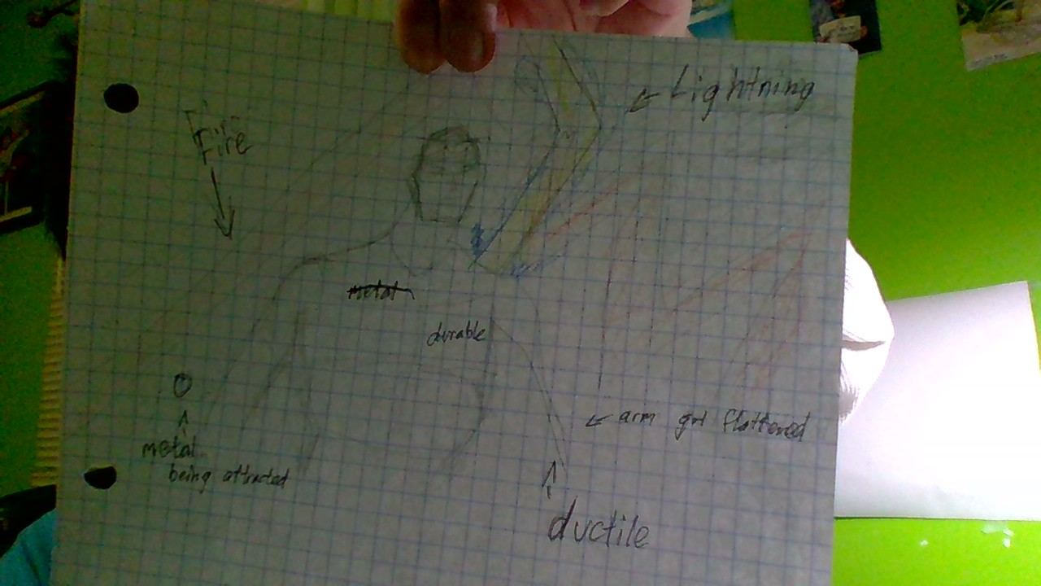

3. Paragraph Rough Draft. Write a biography that introduces the new hero to the world.
It must define the super powers and how they are used by the hero! Be sure to include a topic sentence and conclusion!

TOPIC SENTENCE - Introduce your character and give a general reason why your hero is great. (Don’t use detail or properties yet!)
My superhero’s name is Elemental Man. Elemental Man is a person who was modified in a lab due to an accident he got into several years ago. He is great since he can save people in small spaces, and can be attract weapons from enemies.
EVIDENCE - Tell us about the 5 super powers based on the properties you chose, define them to give detail, tell how the properties are used.

#1: Firstly, Elemental Man is not conductible, which means electricity and heat cannot flow through him. Since he is non-conductible, he cannot be shocked or stunned by his opponents.
#2: Another property that Elemental Man has is hardness, the ability to be scratched. He is durable and will take less damage from enemies.
#3: Next, another property that my superhero, Elemental Man has is non-flammability, or how he doesn’t catch on fire easily. So, if any villains try to light him on fire, the fire would not be very effective.
#4: After that, Elemental Man is ductile because he can be made into a thin layer without breaking. If Elemental Man gets crushed, he will survive since he is ductile.
#5: Last, but not least, Elemental Man is magnetic, which means he has the ability to attract to forces. He can use this ability by attracting the enemies’ weapons if it is made out of a metal or a material that is magnetic.
CONCLUSION - Restate topic sentence. Wrap it all up, make it unique!
Elemental Man is a superhero who is very kind and nice. He can save people in tight and small spaces since he is ductile and has the ability to be made into a thin layer without breaking. Elemental Man is non-conductive, which means that electricity and heat cannot go through his body. Due to this, he cannot get stunned or shocked. Another property that Elemental Man has is hardness, the ability to get scratched. Since he is durable. Then, Elemental Man is also magnetic, attracting metals towards him if he feels like it. He is also non-flammable, meaning that it is hard to ignite him on fire, and that he cannot catch on fire easily. That is Elemental Man and his properties.

